**Weigh Belt Graders**

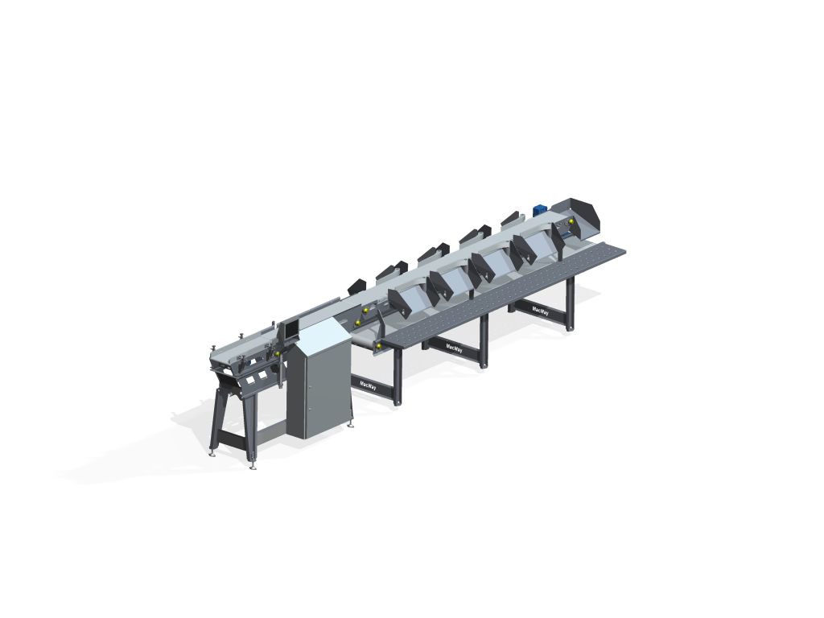

MacWay offer various types of fish Graders for whole fish, fillets or portions both fresh or frozen. With various types of infeed, dynamic weighing, batching and manual-or automatic packing. The graders can be custom made with numerous options all to match your requirements.

**Main Benefits**

* Standard sizing or Custom-made for your requirements
* May include automatic infeed, grading, batching and other features
* Connects to 3rd party or our production software
* MacWay weight belt graders have standard foot print sizing or can be custom-made for each customer, sizes and martial handling is unlimited.
* MacWay design and manufacture belt graders range from simple weight graders to highly sophisticated weigh grading systems that include complete packing solution and integration

**Features**

* Harsh wash down design
* In line or automated infeed
* Accurate and fast weight reading
* Batching count weight smart batch targeting
* Packing machinery or materials design to fit
* Takeaway integration with data collection ERP and traceability
* Software provides real-time monitoring and control capabilities
* MacWay belt graders are equipped with a user-friendly HMI graphical interface
* Comprehensive real-time reporting function that gives the operator a complete overview of the production process. Real-time data generates reports on weight distribution, average weights, a packing overview and packing list, as well as the standard overview.
* Data integration tools to allow other systems to connect
* VSD – Speed and gate timing setting data base by product

**Main use and typical installation**

* Whole Fish grading and batching dual lane systems for volume
* Fillet weight sizing and packing using simple total weight batching
* Smart batching for target batching of retail packs
* Crab grading by weight batch by total weight or count
* Fish landing reports by FV for lobster or Flat fish or other
* Weight grading and batching cooked/ RTE products